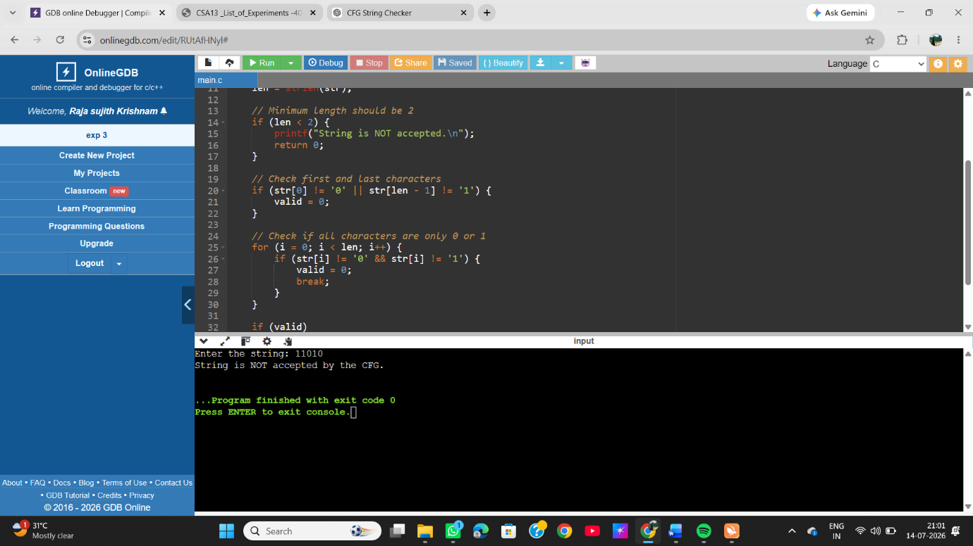
EXP 3 :-Write a C program to check whether a given string belongs to the language defined by a Context Free Grammar (CFG) S → 0A1 A → 0A | 1A | ε

